主标题：AC LED flexible strip, SuperClassic flex series

次标题：AC120V LED Strip light,SMD5050 60LEDs/m 8W/m,450lm/m,14.1*7.3mm

- Product descriptions
- Super clear PVC extrusion make it looks very brilliant and more attractive,
- Premium quality flexible PCB layer assure good heat dissipation, electrical safety and longer maximum length per input,
- Resistant against water, UV radiation, chemicals and abrasion.
- Safe and simple connection system for easy on-site installation after cutting
- Estimated lifetime L70 at Ta25 º C :＞40000h.

2. Product features
◆ 120°wide beam angle
◆ Available in homogeneous white tones,start from 2400K till 12000K
◆ a variety of light color come in red,blue,green,Pink,yellow etc
◆ longer connection length per input of up to 50m
◆ Premium light quality, offer CRI up to Ra90
◆ IP65 rated and for damp or wet locations use

3. Product Size

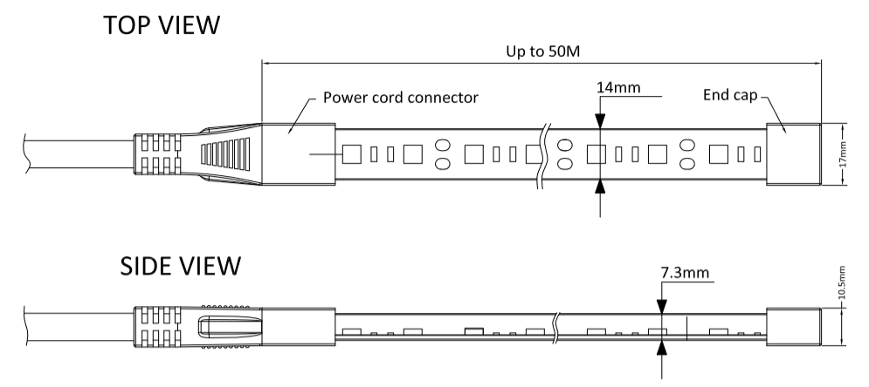

4. Product Technical data
LED Type: | SMD5050
LED Spec: | 22-24lm
LED Qty/m: | 60LEDs/m
Cutting intervals: | 500mm
Overall size: | W(14.1mm)*H(7.3mm)
Input Voltage(V): | AC120V
Dimmable(Y/N): | N/A
Length /Reel: | 25m/Reel,50m/Reel;
Standard Driver type: | Rectifier,8A, IP65
FPC board Spec: | 8mm wide
IP Rating: | IP65
Power factor: | PF>0.9
Storage temperature: | -40 º C to +80 º C
Operating temperature: | -20 º C to +45 º C

- Product Spec sheet
Item no. | Input Voltage(V) | LED Qty/m | Typ.Light color | Typ.color temp. | Typ. power | Typ.Lumen/Meter | Typ.CRI | Cutting Intervals | Maximum length per input
AH-W5050-060-27-## | AC120V | 60LEDs/m | warm white | 2700K | 8W/m | 374LM/M | 80+ | 0.5m | 50m
AH-W5050-060-30-## | AC120V | 60LEDs/m | warm white | 3000K | 8W/m | 392LM/M | 80+ | 0.5m | 50m
AH-W5050-060-40-## | AC120V | 60LEDs/m | Neutral white | 4000K | 8W/m | 450LM/M | 80+ | 0.5m | 50m
AH-W5050-060-65-## | AC120V | 60LEDs/m | Daylight white | 6500K | 8W/m | 480lm/m | 80+ | 0.5m | 50m
--The symbol ## represents the length of LED strips(Unit:m)
--due to unavoidable LED package, electrical component and other machine tolerances, normal input power and lumen tolerance(±10%）exist;

- Suitable Accessories

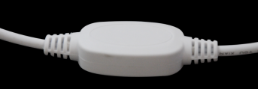
Rectifier, AC120V,8A,PF≥0.9,IP65

7. Installation type
