Proflex,SMD2835,GeneralLite series

- Product descriptions
- 12V or 24V,flexible LED strip with reflective, white surface and 3M adhesive tape on the back.
- LM-80 approved LED of the premium quality with high brightness, 120°beam angle.
- High amount of copper in FPC ensure excellent heat dissipation and Thermally enhanced tape ensures optimum heat transfer.

2. Product features
◆ 120°wide beam angle
◆ High efficacy:up to 150m/W
◆ Available in homogeneous white tones,start from 1800K
◆ LM-80 approved SMD2835 LED package for excellent brightness
◆ only one bin per color for carefree handling and re-ordering
◆ Regular binning within 3 step MacAdam per reel and customized within 2 step MacAdam or in 1 step MacAdam.
◆ Narrower color variance than ANSI standard
◆ Premium light quality, offer CRI up to Ra98 and R9 value up to 80
◆ Easy installation due to solder-free connectors

3. IP Rating briefing

IP20,Naked

IP65 Silicon Surface Dripping

IP65 PU Surface Dripping

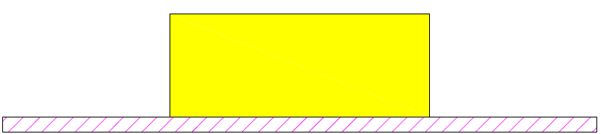
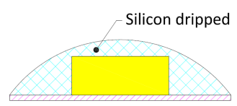
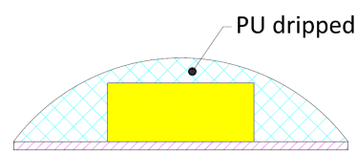

IP68 Solid silicon extrusion

IP 68 PU Tube+PU Surface Dripping

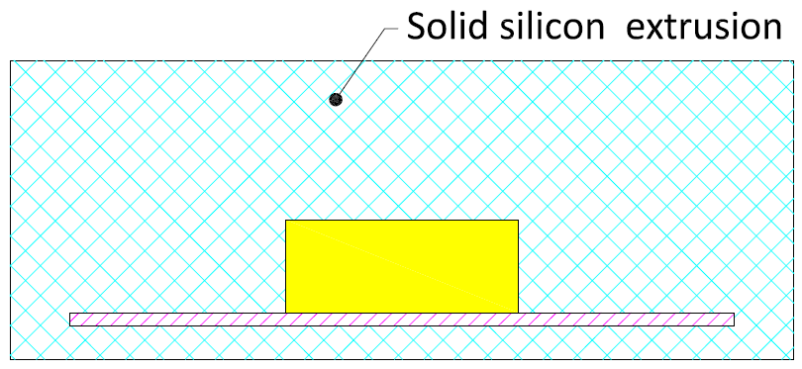
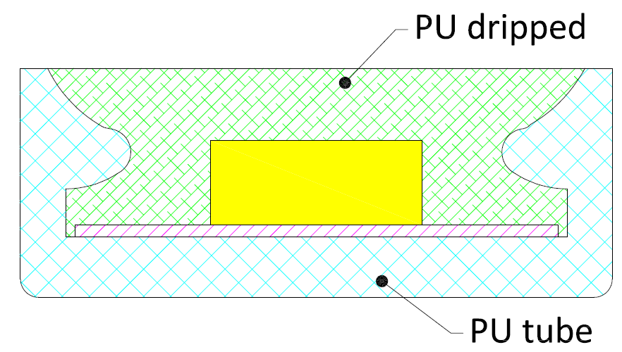
IP65,Nanocoating

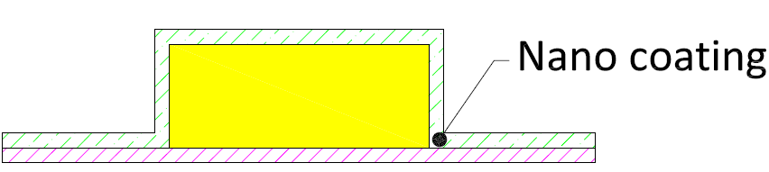

4. Product Technical data
LED Type: | SMD2835
LED Spec: | 24-26lm,26-28lm,28-30lm
LED Chip brand: | Sanan, Epistar
CIE binning: | 1BIN
Regular SDCM: | SDCM≤3,
Customized SDCM: | SDCM≤2,SDCM≤1
Regular CCT(K): | 2300K,2700K,3000K,4000K,6000K
Customized CCT(K): | 1800K,2100K,12000K
CRI: | Ra80+,Ra90+,Ra95+,Ra97+
R9 Value: | 50+,80+,90+
Input Voltage(V): | DC12V,DC24V
Driving mode: | Constant voltage
Dimmable(Y/N): | Y(Compatible with dimmable driver)
Max.run length(m): | 2.5m,5m,10m
Standard Length /Reel: | 5M/Reel,10m/Reel,30m/Reel,50m/Reel
Flexible PCB Spec: | 8mm/10mm/12mm wide, 1OZ or 2OZ back copper layer
IP Rating: | IP20,IP65,IP68
Storage temperature: | -40 º C to +80 º C
Operating temperature: | -20 º C to +45 º C

- Product Spec sheet
5.1 DC12V/24V SMD2835 LED Strips,CRI80+
LED Strip type | LED |  | Input Voltage | LED Qty/M | Luminous flux/W( 4000K) | Input Power/M | CRI | flexible PCB Spec |  | Maximum run lenght | IP Rating
LED Strip type | CIE Bin | SDCM
 |  |  |  |  |  |  |  | W/mm | thickness | Maximum run lenght | IP Rating
DC12V/24V SMD2835 LED Strip,IP20,CRI80+ | 1Bin | ≤3Steps | 12V | 60LEDs | 700LM | 9.6W | 80+ | 8mm | 1 OZ | 5M | IP20
DC12V/24V SMD2835 LED Strip,IP20,CRI80+ | 1Bin | ≤3Steps | 24V | 60LEDs | 760LM | 9.6W | 80+ | 8mm | 1 OZ | 10M | IP20
DC12V/24V SMD2835 LED Strip,IP20,CRI80+ | 1Bin | ≤3Steps | 12V | 60LEDs | 900LM | 14.4W | 80+ | 8mm | 1 OZ | 5M | IP20
DC12V/24V SMD2835 LED Strip,IP20,CRI80+ | 1Bin | ≤3Steps | 24V | 60LEDs | 1000LM | 14.4W | 80+ | 8mm | 1 OZ | 10M | IP20
DC12V/24V SMD2835 LED Strip,IP20,CRI80+ | 1Bin | ≤3Steps | 12V | 120LEDs | 1500LM | 18W | 80+ | 10mm | 2OZ | 5M | IP20
DC12V/24V SMD2835 LED Strip,IP20,CRI80+ | 1Bin | ≤3Steps | 24V | 120LEDs | 1500LM | 18W | 80+ | 10mm | 2OZ | 5M | IP20
DC12V/24V SMD2835 LED Strip,IP20,CRI80+ | 1Bin | ≤3Steps | 12V | 120LEDs | 2000LM | 24W | 80+ | 10mm | 2OZ | 5M | IP20
DC12V/24V SMD2835 LED Strip,IP20,CRI80+ | 1Bin | ≤3Steps | 24V | 120LEDs | 2000LM | 24W | 80+ | 10mm | 2OZ | 5M | IP20
DC12V/24V SMD2835 LED Strip,IP20,CRI80+ | 1Bin | ≤3Steps | 24V | 210LEDs | 3000LM | 30W | 80+ | 12mm | 2OZ | 5M | IP20
DC12V/24V SMD2835 LED Strip,IP65,CRI80+ | 1Bin | ≤3Steps | 12V | 60LEDs | 630LM | 9.6W | 80+ | 8mm | 1 OZ | 5M | IP65
DC12V/24V SMD2835 LED Strip,IP65,CRI80+ | 1Bin | ≤3Steps | 24V | 60LEDs | 690LM | 9.6W | 80+ | 8mm | 1 OZ | 10M | IP65
DC12V/24V SMD2835 LED Strip,IP65,CRI80+ | 1Bin | ≤3Steps | 12V | 60LEDs | 810LM | 14.4W | 80+ | 8mm | 1 OZ | 5M | IP65
DC12V/24V SMD2835 LED Strip,IP65,CRI80+ | 1Bin | ≤3Steps | 24V | 60LEDs | 900LM | 14.4W | 80+ | 8mm | 1 OZ | 10M | IP65
DC12V/24V SMD2835 LED Strip,IP68,CRI80+ | 1Bin | ≤3Steps | 12V | 60LEDs | 630LM | 9.6W | 80+ | 8mm | 1 OZ | 5M | IP68
DC12V/24V SMD2835 LED Strip,IP68,CRI80+ | 1Bin | ≤3Steps | 24V | 60LEDs | 690LM | 9.6W | 80+ | 8mm | 1 OZ | 10M | IP68
DC12V/24V SMD2835 LED Strip,IP68,CRI80+ | 1Bin | ≤3Steps | 12V | 60LEDs | 810LM | 14.4W | 80+ | 8mm | 1 OZ | 5M | IP68
DC12V/24V SMD2835 LED Strip,IP68,CRI80+ | 1Bin | ≤3Steps | 24V | 60LEDs | 900LM | 14.4W | 80+ | 8mm | 1 OZ | 10M | IP68

5.2 DC12V/24V SMD2835 LED Strips,CRI90+
LED Strip type | LED |  | Input Voltage | LED Qty/M | Luminous flux/W( 4000K) | Input Power/M | CRI | flexible PCB Spec |  | Maximum run lenght | IP Rating
LED Strip type | CIE Bin | SDCM
 |  |  |  |  |  |  |  | W/mm | thickness | Maximum run lenght | IP Rating
DC12V/24V SMD2835 LED Strip,IP20,CRI90+ | 1Bin | ≤3Steps | 12V | 60LEDs | 610LM | 9.6W | 90+ | 8mm | 1 OZ | 5M | IP20
DC12V/24V SMD2835 LED Strip,IP20,CRI90+ | 1Bin | ≤3Steps | 24V | 60LEDs | 662LM | 9.6W | 90+ | 8mm | 1 OZ | 10M | IP20
DC12V/24V SMD2835 LED Strip,IP20,CRI90+ | 1Bin | ≤3Steps | 12V | 60LEDs | 783LM | 14.4W | 90+ | 8mm | 1 OZ | 5M | IP20
DC12V/24V SMD2835 LED Strip,IP20,CRI90+ | 1Bin | ≤3Steps | 24V | 60LEDs | 870LM | 14.4W | 90+ | 8mm | 1 OZ | 10M | IP20
DC12V/24V SMD2835 LED Strip,IP20,CRI90+ | 1Bin | ≤3Steps | 12V | 120LEDs | 1305LM | 18W | 90+ | 10mm | 2OZ | 5M | IP20
DC12V/24V SMD2835 LED Strip,IP20,CRI90+ | 1Bin | ≤3Steps | 24V | 120LEDs | 1305LM | 18W | 90+ | 10mm | 2OZ | 5M | IP20
DC12V/24V SMD2835 LED Strip,IP20,CRI90+ | 1Bin | ≤3Steps | 12V | 120LEDs | 1740LM | 24W | 90+ | 10mm | 2OZ | 5M | IP20
DC12V/24V SMD2835 LED Strip,IP20,CRI90+ | 1Bin | ≤3Steps | 24V | 120LEDs | 1740LM | 24W | 90+ | 10mm | 2OZ | 5M | IP20
DC12V/24V SMD2835 LED Strip,IP20,CRI90+ | 1Bin | ≤3Steps | 24V | 210LEDs | 2610LM | 30W | 90+ | 12mm | 2OZ | 5M | IP20
DC12V/24V SMD2835 LED Strip,IP65,CRI90+ | 1Bin | ≤3Steps | 12V | 60LEDs | 549LM | 9.6W | 90+ | 8mm | 1 OZ | 5M | IP65
DC12V/24V SMD2835 LED Strip,IP65,CRI90+ | 1Bin | ≤3Steps | 24V | 60LEDs | 596LM | 9.6W | 90+ | 8mm | 1 OZ | 10M | IP65
DC12V/24V SMD2835 LED Strip,IP65,CRI90+ | 1Bin | ≤3Steps | 12V | 60LEDs | 705LM | 14.4W | 90+ | 8mm | 1 OZ | 5M | IP65
DC12V/24V SMD2835 LED Strip,IP65,CRI90+ | 1Bin | ≤3Steps | 24V | 60LEDs | 783LM | 14.4W | 90+ | 8mm | 1 OZ | 10M | IP65
DC12V/24V SMD2835 LED Strip,IP68,CRI90+ | 1Bin | ≤3Steps | 12V | 60LEDs | 549LM | 9.6W | 90+ | 8mm | 1 OZ | 5M | IP68
DC12V/24V SMD2835 LED Strip,IP68,CRI90+ | 1Bin | ≤3Steps | 24V | 60LEDs | 596LM | 9.6W | 90+ | 8mm | 1 OZ | 10M | IP68
DC12V/24V SMD2835 LED Strip,IP68,CRI90+ | 1Bin | ≤3Steps | 12V | 60LEDs | 705LM | 14.4W | 90+ | 8mm | 1 OZ | 5M | IP68
DC12V/24V SMD2835 LED Strip,IP68,CRI90+ | 1Bin | ≤3Steps | 24V | 60LEDs | 783LM | 14.4W | 90+ | 8mm | 1 OZ | 10M | IP68
Notes:
--the typical lumen as shown in the table above per meter is related to 4000K, warmer light color such as 2400K,2700K is reduced and colder light color such as 5000K,6500K is increased.
--due to unavoidable LED package, electrical component and other machine tolerances, normal input power and lumen tolerance(±10%）exist;

