主标题：AC LED Neon Flex, Middle Square C-Bend

次标题：AC120V LED Neon flex,8W/3FT,10*20mm,260lm

- Product descriptions
- Uniform,absolutely homogeneous illumination,
- LM-80 approved LED of the premium quality with high brightness,
- High amount of copper in FPC ensure excellent heat dissipation,
- UL2388 standard bus conductor sectional area assure the excellent electrical safety,
- Resistant against water, UV radiation, chemicals and abrasion.
- Safe and simple connection system for easy on-site installation after cutting
- Estimated lifetime L70 at Ta＜45°C:＞50000h.

2. Product features
◆ Available in homogeneous white tones,start from 1800K
◆ a variety of light color come in red,blue,green,Pink,yellow etc
◆ shorter cutting intervals of down to 18",
◆ longer connection length per input of up to 165FT
◆ Premium light quality, offer CRI up to Ra90
◆ IP65 or IP68 rated and for damp or wet locations use
◆ Easy installation due to optional solder-free connectors

3. Product Size
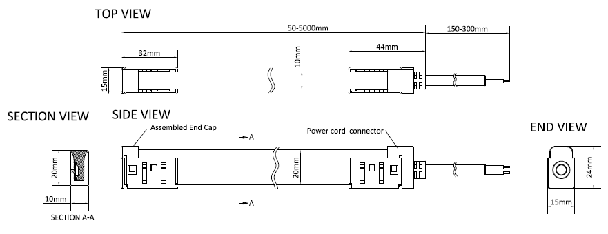

4. Product Technical data
LED Type: | SMD2835,
Cutting intervals: | 18”
Overall size: | W(10mm)*H(20mm)
Maximum length per input | 165FT
Input Voltage(V): | AC120V
Length /Reel: | 165FT/Reel
Flexible PCB Spec: | 8mm wide,
IP Rating: | IP65,IP67
Storage temperature: | -40 º C to +80 º C
Operating temperature: | -20 º C to +45 º C

- Product Spec sheet
Item no. | Light color | Typ.color temp. | Typ.power | Typ.Lumen/3FTeter | Typ.CRI | Cutting Intervals | Maximum length per input
AH-NF120V-1020-18-## | Super warm white | 1800K | 8w/3FT | 162lm/3FT | 80+ | 18" | 165FT
AH-NF120V-1020-27-## | super warm white | 2700K | 8w/3FT | 216lm/3FT | 80+ | 18" | 165FT
AH-NF120V-1020-30-## | warm white | 3000K | 8w/3FT | 227lm/3FT | 80+ | 18" | 165FT
AH-NF120V-1020-40-## | Neutral white | 4000K | 8w/3FT | 260lm/3FT | 80+ | 18" | 165FT
AH-NF120V-1020-50-## | Cool white | 5000K | 8w/3FT | 280lm/3FT | 80+ | 18" | 165FT
AH-NF120V-1020-65-## | Daylight white | 6500K | 8w/3FT | 290lm/3FT | 80+ | 18" | 165FT
AH-NF120V-1020-RE-## | Red |  | 8w/3FT |  |  | 18" | 165FT
AH-NF120V-1020-BL-## | Blue |  | 8w/3FT |  |  | 18" | 165FT
AH-NF120V-1020-GR-## | Green |  | 8w/3FT |  |  | 18" | 165FT
AH-NF120V-1020-YE-## | Yellow |  | 8w/3FT |  |  | 18" | 165FT

- Suitable Accessories
6.1 Power cord connector kits

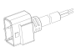 | IP67 2Pins In-feeder unit with 0.5M power cord
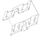 | Inner Clip
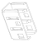 | Base Bracket

6.2 End cap kits
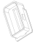 | IP67 End cap
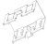 | Inner Clip
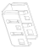 | Base Bracket

6.3 Mounting Aluminium profile
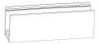 | 165FTm , aluminium profile, width**, height**
 | 500mm , aluminium profile, width**, height**
 | 18" , aluminium profile, width**, height**

